Three Fundamental features of Network Security
- Confidentiality: Confidentiality is roughly equivalent to privacy. If I send a message to someone, only they should be able to read that message
- Integrity: When I receive a message, I want to know that it hasn’t been altered in transit.
- Authentication: When I receive a message I should be confident on who actually it has come from.
Feistal Cipher
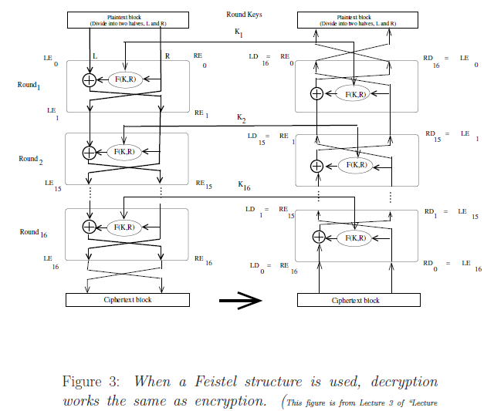

Example:


